CONFIDENTIAL

RESEARCH MANAGEMENT CENTRE
Innovation and Commercialization Office
Tel: 03-6196 6346/ 5454 Fax: 03-6196 4862
COPYRIGHT DISCLOSURE
FORM
Kindly disclose your invention through this IP Disclosure Form for IP Protection and Registration.

PART 1: IDENTIFICATION
- Principal Inventor Identification
1
NAME OF PRINCIPAL INVENTOR
IC / PASSPORT NO.
DEPARTMENT / KULLIYAH
CORRESPONDENCE ADDRESS
EMAIL
TELEPHONE NO.

Please state the details of the inventor / originator and any of the co-inventor(s) in Attachment 1.

 |  |  | Intellectual Property |  |  |  | Sub Type
 |  |  |  | Copyright |  |  |  |  |  | Literary |  |  |  | Musical |  |  |  | Artistic
 |  |  |  |  |  |  |  |  |  | Film |  |  |  | Sound |  |  |  | Others

PART 2: DESCRIPTION OF DISCLOSURE
- Title of disclosure
______________________________________________________________________________
______________________________________________________________________________
______________________________________________________________________________
______________________________________________________________________________

- Brief Description of the Disclosure

______________________________________________________________________________
______________________________________________________________________________
______________________________________________________________________________
______________________________________________________________________________
_____________________________________________________________________________
______________________________________________________________________________
______________________________________________________________________________
- Usage of the Disclosure
______________________________________________________________________________

______________________________________________________________________________
______________________________________________________________________________

- Please attach the document below

Detail backgrounds, description, and the document file.
The originality report by plagiarism software (TurnItIn) for manuscript (A must for Copyright Disclosure - only originality report with green range (1-24%) will be considered )

Please attach form CR-1, filling up the form Applicant, Section A, Section B, Section C. Please fill up multiple Section C if there is more than 1 author for the copyright

5. Date of document fixation/first created

_______ (DD) /_______ (MM) /________ (YYYY)

PART 3: SOURCE OF RESEARCH PROJECT(S) RESULTING TO THIS DISCLOSURE
- Funded Project
Fund Type | Project Code | Start / End | Fund Amount | Fund Allocation of IP
IRPA / FRGS / SF/ TF/ RIGS / | 01-03-06-SF1001 | 31/07/2015 – 30/06/2017 | RM 254,000 | RM 20,000

- Obligation to Funded Project
Do you have any obligation to the funded project eg. Disclosure of IP, commercial grant of rights (option/license) ? |  | Yes |  | No
Please specify any obligation to the funder

________________________________________________________________________________

- Project Cost Estimation
Please estimate the cost leading to the invention (please refer to Attachment 6 for the sample data)

Vote | Items Details | Estimated Cost (RM) | Source of Fund | Notes
Wages / Cost of RA
Travel and Transportation
Rentals
Research Materials Supplies
Modifications and Repairs
Special Services
Equipment and Accessories
Total

PART 5: COMMERCIAL POTENTIAL
- Please circle the stage of the disclosure

- Can this invention be exploited for commercialization directly, or does it need further development?

_______________________________________________________________________________________

- If there is commercial potential, please do initial competitor analysis as per Attachment 3.

Attachment 3 Initial Competitor Analysis

- Please state if there is any inquiry on the Invention from the industry.

Yes No
If yes, please specify and state name of the interested party.

_______________________________________________________________________________________
PART 6: DECLARATION AND RECOMMENDATION
DECLARATION
I have discussed this intellectual property with the Head of Research representative for my Kulliyyah

I have discussed the content of this intellectual property disclosure and obtained consent for its submission with my co-inventor/s and co-contributor/s
I understand that the assignment of the Intellectual Property Right to International Islamic University shall follow IIUM Policies and Guidelines for Intellectual Property Rights and Commercialization
I promise to work with RMC / assigned expert / agents to complete the full registration of my intellectual property
I declare that this disclosure is an original work and belongs to the undersign and the listed inventor, and I / We will be responsible for any infringement

______________________________ ____________________________
Signature of Principle Inventor Date authority
RECOMMENDATION OF THE DEPARTMENT
______________________________ ____________________________
Signature and name of the approving Date authority
RECOMMENDATION OF THE KULLIYYAH
______________________________ ____________________________
Signature and name of the approving Date authority

Attachment 1: List of Inventors and Co-Inventors

Name | Department / Kulliyyah | Type | No of Man Hour Spent | Contribution % | IC / Passport No. | Address | Tel No
Name of Inventor / Co Inventor / Investigator / Co Investigator / Contributor | Department / Kulliyah | - IIUM Faculty (Title and grade)  - IIUM Staff (Title and Grade)  - Student (Undergrad / Grad / Post Grad / Post Doc)  - Ex-Student / Non IIUM (Please state University / Industry) | Total man-hours spent on the invention | % Contribution to the invention (not necessarily correspond to man-hours spent)
Total |  |  |  | 100%

Attachment 3: Competitor Analysis

Only for Invention that has potential commercialization

Product Name | Manufacturer / Producer | Model | Competitor Price | Product attributes | Comparison to the disclosed IP
Payung ACME | ACME | ACME 123 | RM 2,000 | A fire protection umbrella, which comprises a fire-proof umbrella cover coated with fire retarding paint and fully covered with ceramic elements or ceramic wafers. A flash light is attached to the handle of the umbrella to produce light. A hood is attached to the bottom of the umbrella cover to cover one's head on an emergency. The umbrella ribs may be bound up with the shaft of the umbrella frame by a cord to prevent the umbrella cover from collapse in counter direction so that the umbrella may be used as a parachute to help one escape from a high-raised building.

Attachment 4: Definition of IPR

Type of IPR | Definition | Duration of Protection | Notes
Copyright | Copyright is the exclusive right to control creative works created by the author, copyright owner and performer for a specific period governed under the Copyright Act 1987. | Literary, Musical or Artistic Works  Generally, - 50 years after the death.  Film, Sound Recordings and Performer  50 years from the work was published  Broadcasts  50 from the which the broadcasts was first made. | WORKS ELIGIBLE FOR COPYRIGHT  - literary works;  - musical works;  - artistic works;  - films;  - sound recordings;  - broadcasts; and  - derivative works

Attachment 5: IIUM Guideline for Intellectual Property Disclosure at various stage of R&D&C&I

Please note that the graphical diagram is only a guideline of the stage to disclose Intellectual Property at IIUM. Actual disclosures and filing of intellectual properties can occur at any of the stage

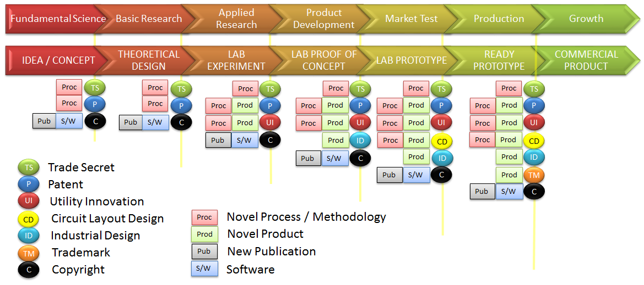

Technology Readiness Level

TRL |  | Description
1 | Ideation | Basic Principles are observed and reported
2. | Innovation begins | Basic principles observed so practical applications can be formulated
3. | Proof of Concept | Analytical and laboratory studies are required to see if the technology is viable
4. | Component Test | Laboratory testing of the prototype component
5. | Prototype construction | Laboratory testing of the integrated system
6. | Alpha Testing | Prototype system demonstrated in an operational environment
7 | Beta Testing | Completed design tested in real environment
8. | Certification | Proven to work under its expected conditions and certified to be used
9 | System Proven to be successfully function | Ready for commercial deployment
9+ | Product is launched commercially
TPM Definition of TRL
https://www.youtube.com/watch?v=in4TnQZGYj4

Attachment 6: Sample Cost Estimation

Project Cost Estimation
Please estimate the cost leading to the invention (please use the example below)

Vote | Items Details | Estimated Cost (RM) | Source of Fund | Notes
V11000 Wages | Research Assistant | 60,000 | FRGS
V21000 Travel and Transportation | Local and Overseas Travel | 21,000 | FRGS
V24000 Rentals | Usage of EE Lab | 20,000 | IIUM Operating Expense | The use of Lab for 6 months
V26000 Research Materials and Supplies | Raw materials | 25,000 | FRGS, IIUM Operating Expense | Chemical and electronic parts
V28000 Modifications and Repairs | Spare parts replacement / Calibration | 5,000 | IIUM Operating Expense
V29000 Special Services | External Lab charges / Outsourcing / External consultant | 20,000 | FRGS, IIUM Operating Expense
V35000 Equipment and Accessories | New equipment | 120,000 | FRGS
Total |  | RM 271,000

