Researcher User Manual
RESEARCH MANAGEMENT SYSTEM VERSION 2 (RMS V2)
Researcher User Manual Version 1.00
Grant Application Module

This document contains the Researcher User Manual for the IIUM Research Management System.

Htech Solutions Asia Pacific (M) Sdn. Bhd.

Document Control

General Information

Document Title | IIUM Research Management System - Researcher User Manual
Prepared For | Research Management Centre ,IIUM
Date Prepared | 1 March 2017
Update Date | 26 April 2017
Contract Reference
Version | 1.0 (Release)

Verification,Certification and Approval

Activity | Name/Position | Signature | Date
Prepared By | Mohd Nazri Amdan  Junior System Analyst  Htech Solutions
Prepared By | Fakhrul Azman Ali  System Analyst  Htech Solutions
Reviewed By | Zuliana Zubir  Lead Technical  RMC, IIUM

Revision Log

Version | Date | Description
0.1 | 1 Mar 2017 | First Draft Release
0.2 | 15 Mar 2017 | Second Draft Release
1.0 | 25 Apr 2017 | First Release (User Sign Off)

TABLE OF CONTENTS
TABLE OF CONTENTS 4
Introduction 5
Purpose 5
Target Audience 5
Login 5
DashBoard 6
Researcher - Profile 7
Follow the steps below to access the profile. 7
Step 1. Click on Profile on the side menu. Researcher’s Profile can be viewed only. 7
Researcher - Request Submission 8
Research Application 8
Step 1. Click on Request Submission on the side menu and select Research Application from the research drop down. 8
Step 2. Select Grant Type, Research Type and Research Area for the project. 8
8
Step 3. Identification. Fill the following required fields: 9
Step 4. Click button orbutton to navigate through the application form. 9
Step 5. Researchers Background 9
Step 5a. Add Participants (Staff) 10
Step 5b. Add Participants (External) 10
Step 6. Click button orbutton to navigate through the application form. 11
Step 7. Proposal Details 11
Step 8. Add objective(s) 12
Step 9. Expected Results/Benefits 12
Step 10. Add Milestones 13
Step 11. Add Budget details 14
Step 12. Upload document(s) 15
Step 13. Save as Draft or Submit Application 15

Introduction

Purpose

This document covers how to use the Research Management System Version 2 (RMSV2) - Researcher User Manual

Target Audience

The target audiences for this User Manual include:-
- Researchers
- Research Management Center Officers

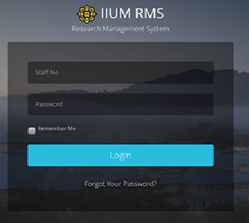
Login
In a web browser, enter the following address:-

https://rmsv2.iium.edu.my

In the screen, enter your valid HURIS username and password. Then click the LOGIN icon as depicted on screen.

Dash Board
This is the first screen displayed when user successfully logins to the system.

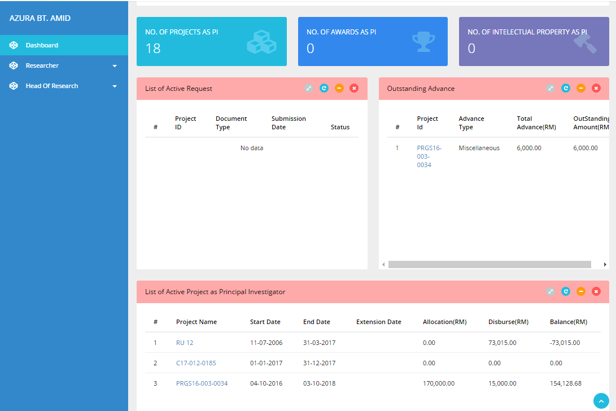
The Dashboard consists of :
- Menu on the left
- Information Summary for the user such as
  - Number of projects which user is the Principal Investigator
  - No of awards received which user is the Principal Investigator
  - No of Intellectual Properties which user is the Principal Investigator
  - List of Active Request
  - Outstanding Advance
  - List of Active Project as Principal Investigator

Researcher - Profile
Researcher Information is extracted from Human Resource Information System.(HURIS) This data is read only information from HURIS. If there is any discrepancy, please contact HURIS directly.

Follow the steps below to access the profile.

Step 1. Click on Profile on the side menu. Researcher’s Profile can be viewed only.
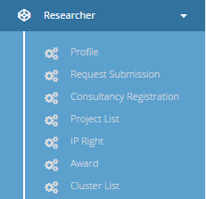

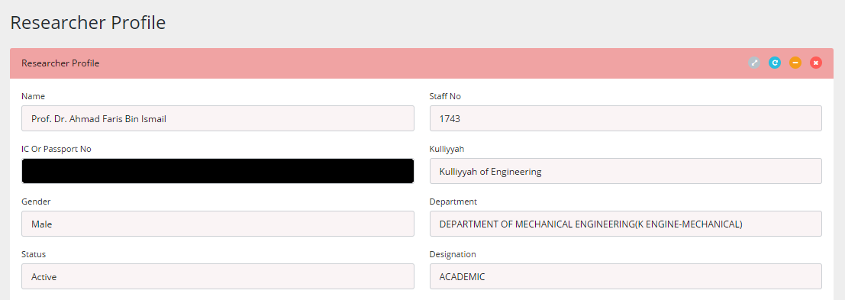

Researcher - Request Submission

Research Application
To apply for research application that currently opens.

Take note that only grant types currently opened are listed in the dropdown menu of the Grant Type.

Follow the steps below to complete the application.

Step 1. Click on Request Submission on the side menu and select Research Application from the research drop down menu.

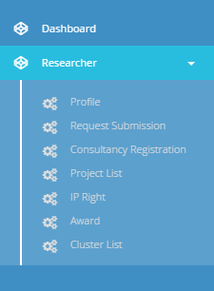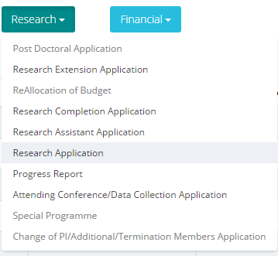

Step 2. Select Grant Type, Research Type and Research Area for the project.
- Click button to proceed
- Your application will be saved as draft
- You can edit or delete your draft application from Request Submission.

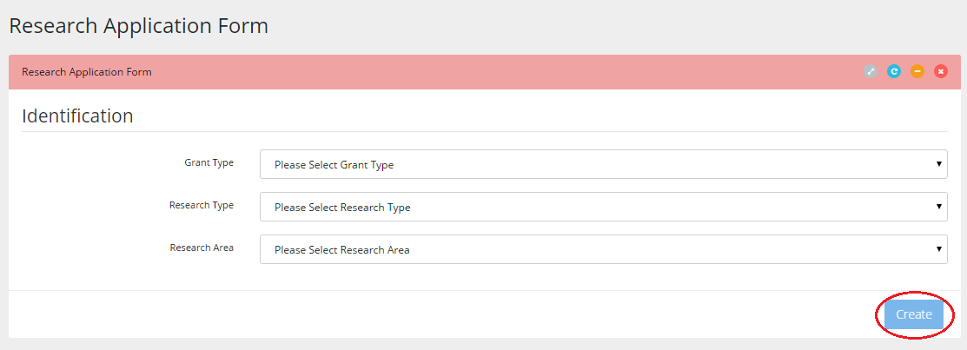

Step 3. Identification. Fill the following required fields:

- Research Title
- Summary
- Research Duration Date (Start Date & End Date

Step 4. Click button orbutton to navigate through the application form.
- Click next to proceed
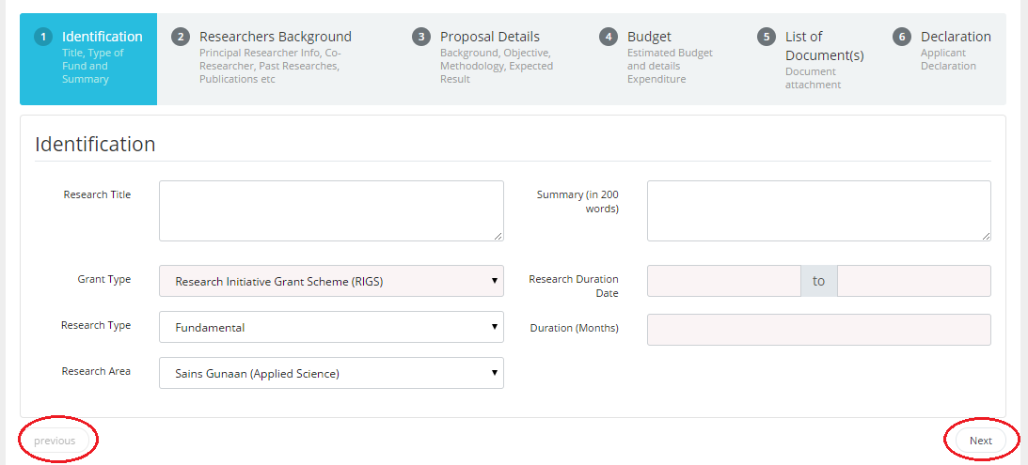

Step 5. Researchers Background
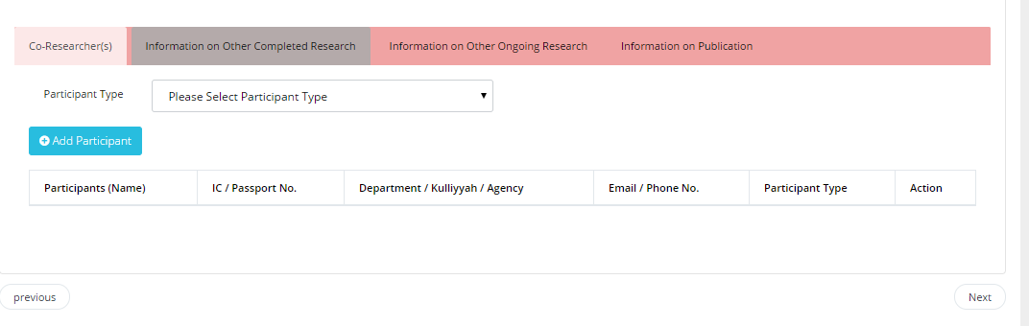

Step 5a. Add Participants (Staff)

- Select “Staff” from Participant Type
- Search staff no or name then hit button
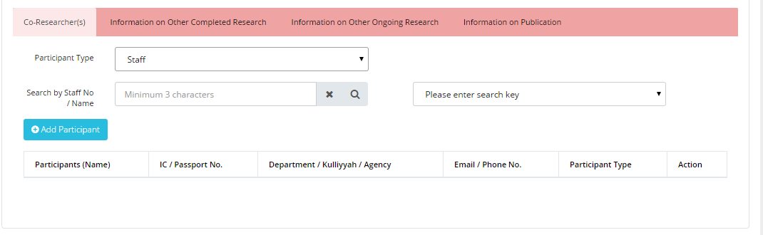
- Select one from options listed and click button.
- Click button if you want to remove any.
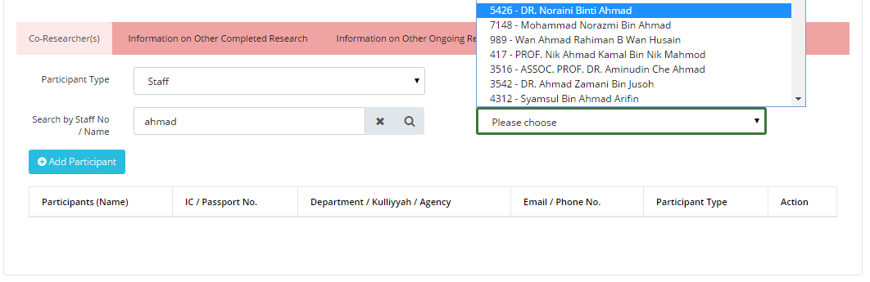

Step 5b. Add Participants (External)
- Select “External” from Participant Type and click button.
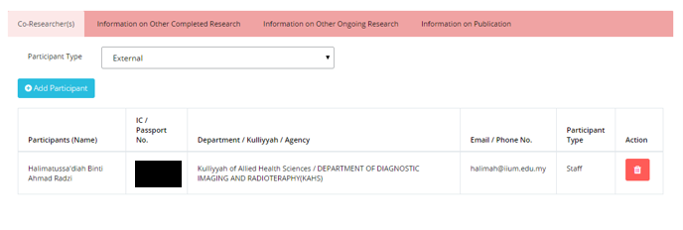

- Fill in all required fields.
- Click button if you want to remove any.
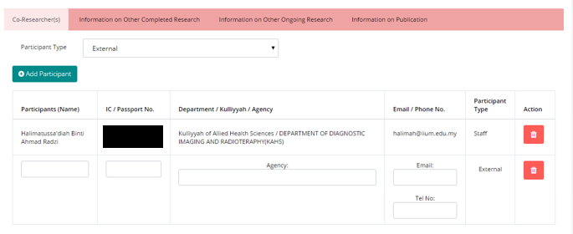

Step 6. Click button orbutton to navigate through the application form.
- Click next to proceed

Step 7. Proposal Details
- Fill in “Executive Summary” fields.
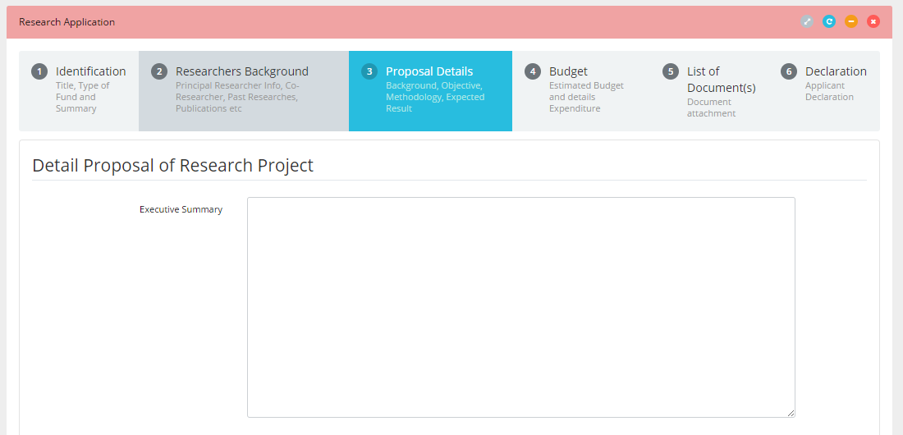

Step 8. Add objective(s)
- Fill in “Objective” field.
- Click button to add more objective.
- Clickto remove any objective.

Step 9. Expected Results/Benefits
- Fill in details for “Publication”, “Human Capital” and “IP”.
- Clickbutton to add more item.
- Clickto remove any items.

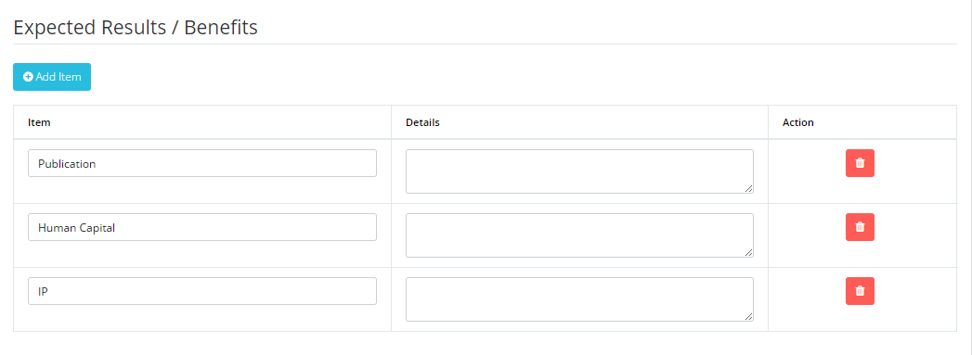

Step 10. Add Milestones

- Fill in Milestone, Start Date, End Date and Percentage fields.

- Clickbutton to add more milestone

- Click button to add more activity for that particular Milestone.

- Click to remove any Activity or Milestone.

- Click next to proceed
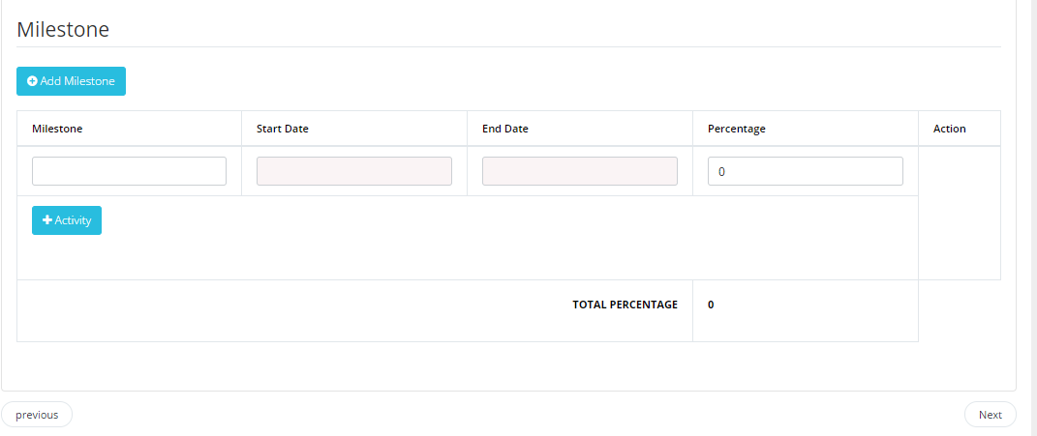

Step 11. Add Budget details

- Insert amount of requested by vote respectively. Note that every vote have its limit prior to project type.
- Click to add more year.
- Clickbutton to remove that particular year.
- Click next to proceed.
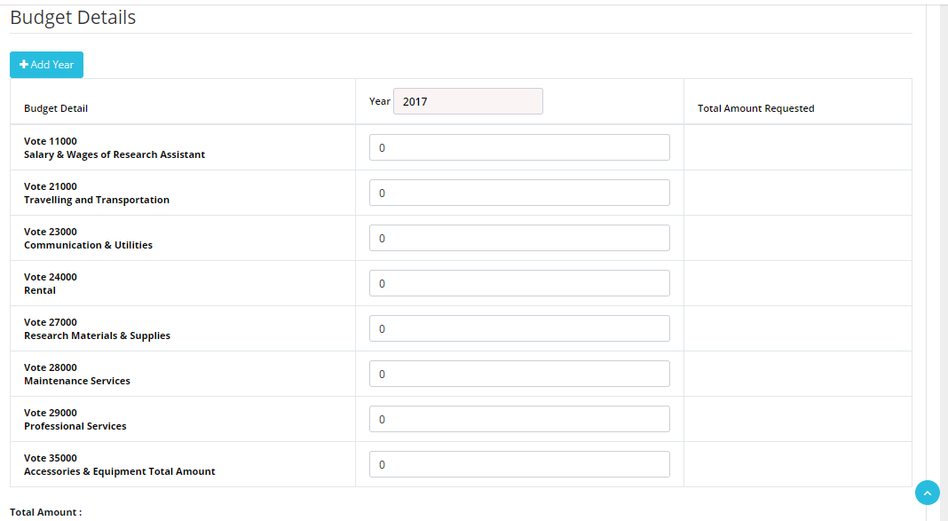

Step 12. Upload document(s)

- Click button to add more fields and browse file to be uploaded.
- Click button to remove any files.
- Click next to proceed.
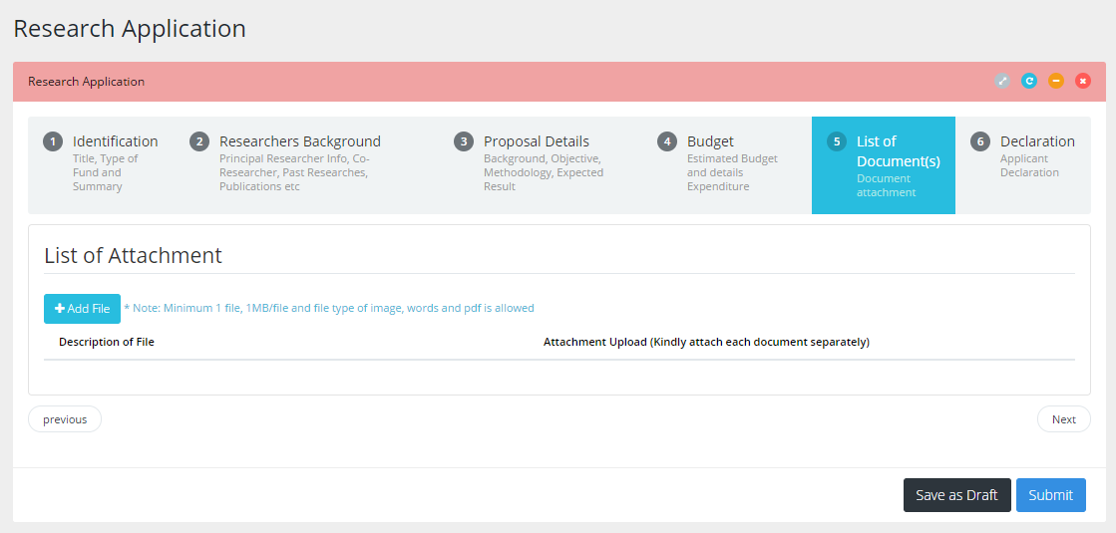

Step 13. Save as Draft or Submit Application
- Click button to save application and edit later.
- Tick at declaration box.
- Click button to submit the application to RMC.

